



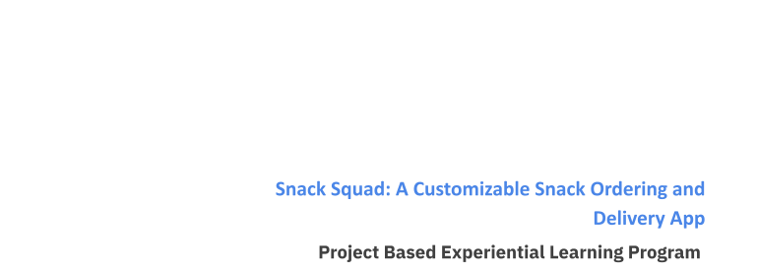

Handbook SmartBridge Educational Services Pvt. Ltd.@

# Snack Squad: A Customizable Snack Ordering and Delivery App

A project that demonstrates the use of Android Jetpack Compose to build a UI for a snack squad app. Snack Squad is a sample project built using the Android Compose UI toolkit. It demonstrates how to create a simple e-commerce app for snacks using the Compose libraries.The user can see a list of snacks, and by tapping on a snack,and by tapping on the "Add to Cart" button, the snack will be added to the cart. The user can also see the list of items in the cart and can proceed to checkout to make the purchase.

**Architecture**

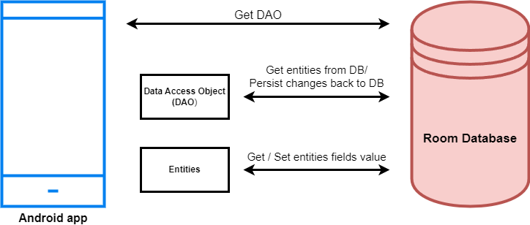

**Learning Outcomes :**

By end of this project:

* You’ll be able to work on Android studio and build an app.
* You’ll be able to integrate the database accordingly.

**Project Workflow:**

* Users register into the application.
* After registration , user logins into the application.
* User enters into the main page
* User can view the items,select and order the items
* From admin login we can view the orders placed.

**Tasks:**

1.Required initial steps

2.Creating a new project.

3.Adding required dependencies.

4.Creating the database classes.

5.Building application UI and connecting to database. 6.Using AndroidManifest.xml

7.Running the application.

**Task 1:**

Required initial steps : <https://developer.android.com/studio/install>

**Task 2 :**

Creating a new project.

Step 1 : Android studio > File > New > New Project > Empty Compose Activity Step 2 : Click on **Next** button.

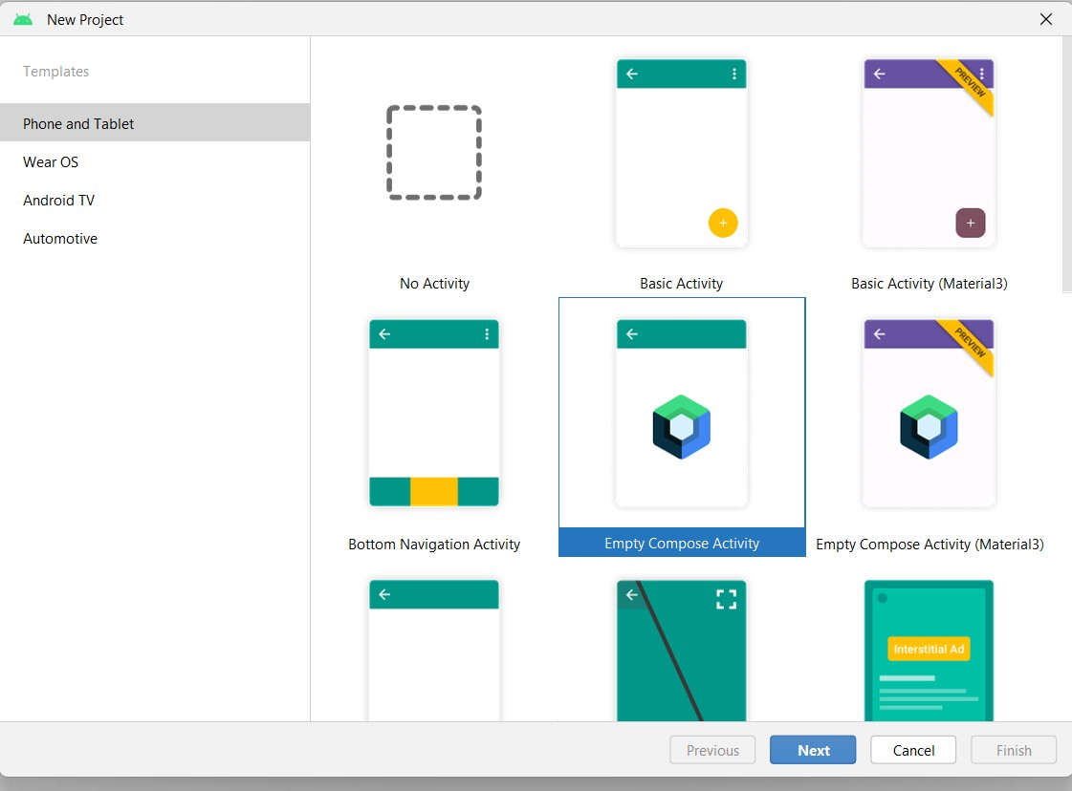

Step 3 : Give name to the new project.

Step 4 : Give the Minimum SDK value

Step 5 : Click Finish

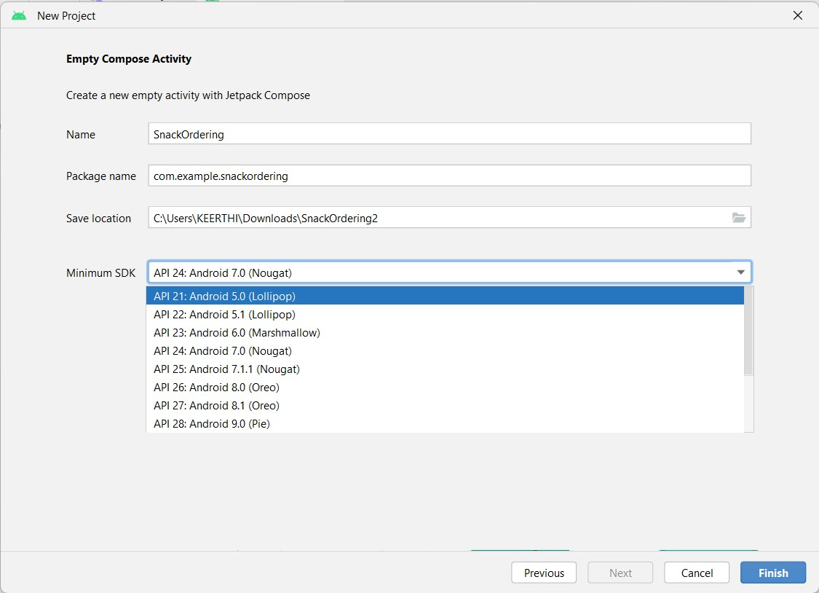

Main activity file

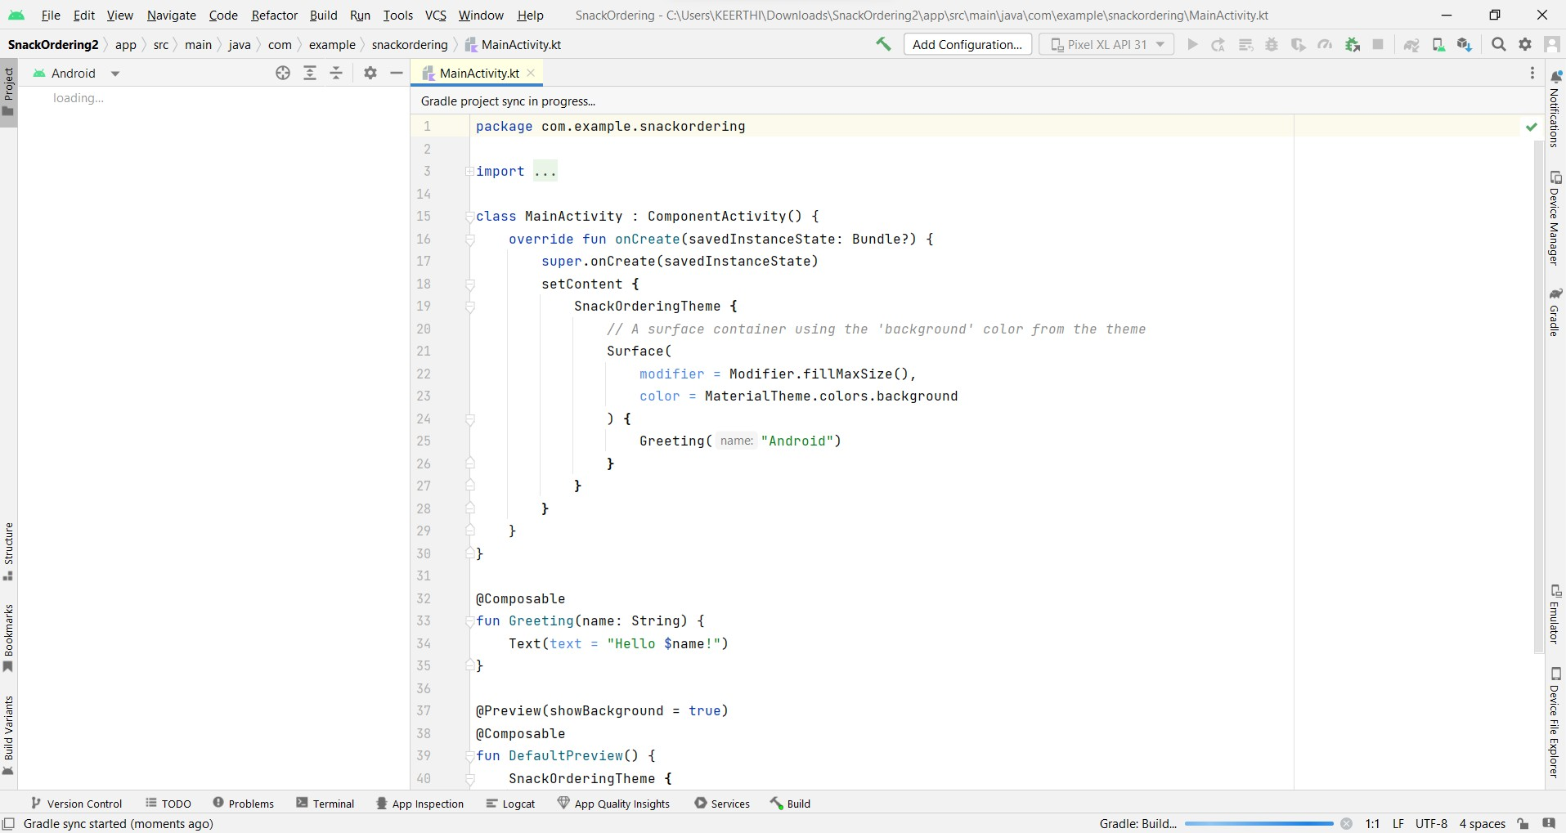

**Task 3 :**

Adding required dependencies.

Step 1 : Gradle scripts > build.gradle(Module :app)

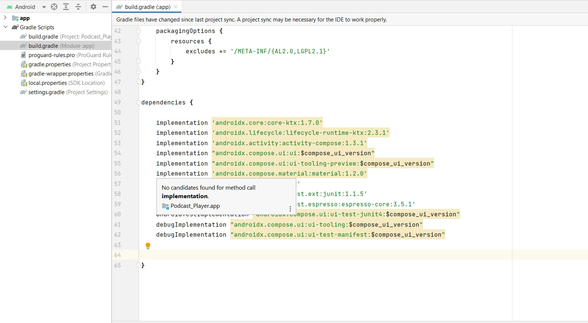

Step 2 : Adding room dependencies.

Add the below code in dependencies

*// Adding Room dependencies*

implementation 'androidx.room:room-common:2.5.0' implementation 'androidx.room:room-ktx:2.5.0'

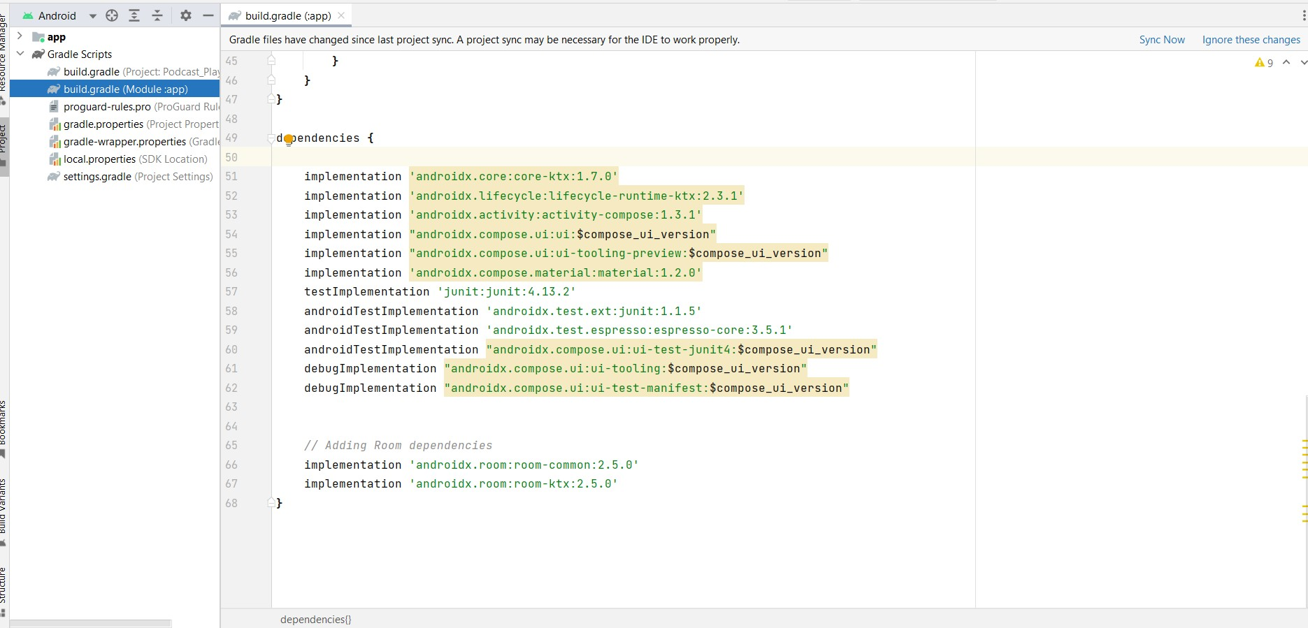

Step 3 : Click on Sync now

**Task 4:**

Creating the database classes.

In this project we will be having two databases, one is for user registration and login, and other is for tracking the orders of the user, which is used for admin page .

Database 1

Step 1 : Create User data class

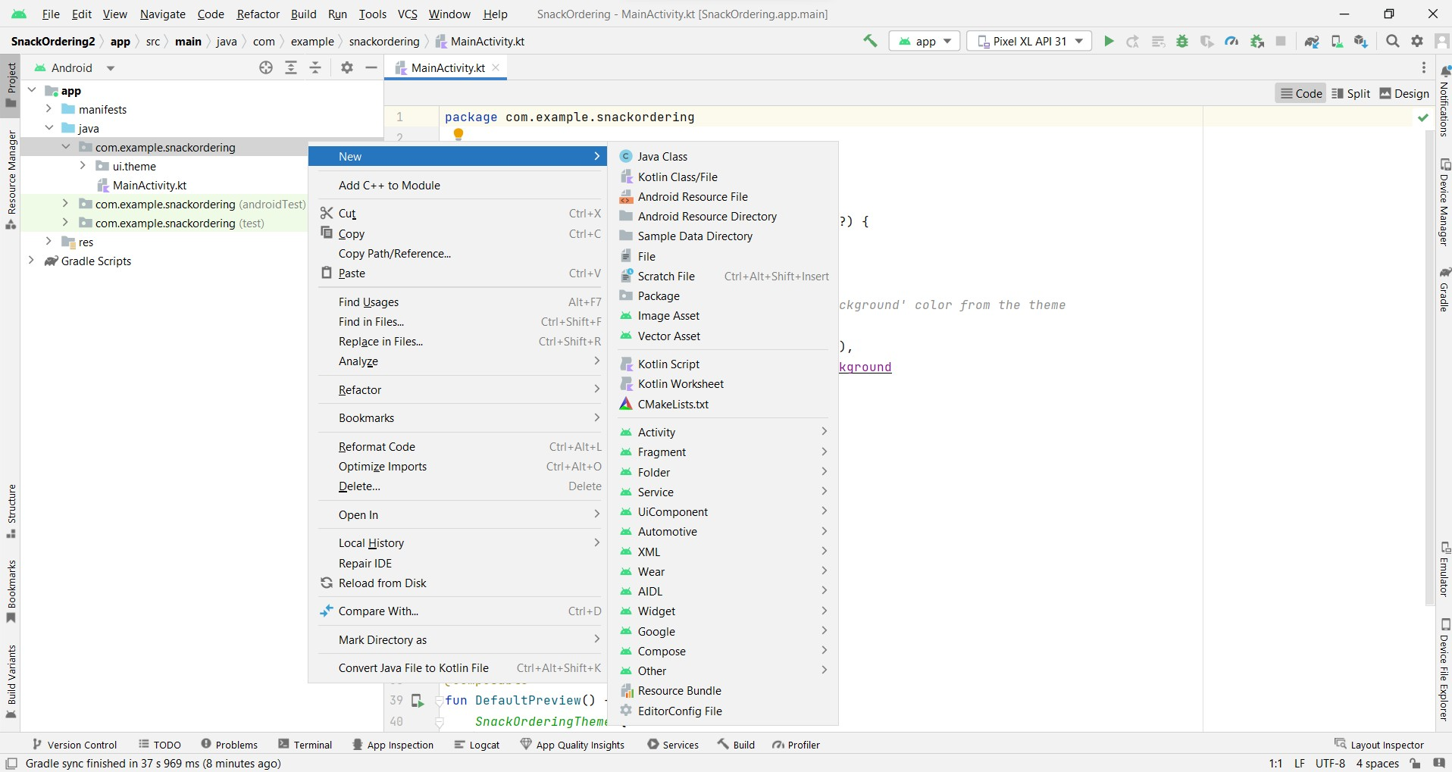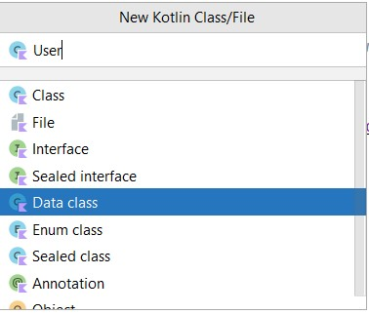

User class code:

[https://github.com/smartinternz02/SnackOrdering/tree/main/app/src/main/java/com/e xample/snackordering/User.kt](https://github.com/smartinternz02/SnackOrdering/tree/main/app/src/main/java/com/example/snackordering/User.kt)

Step 2 : Create an UserDao interface



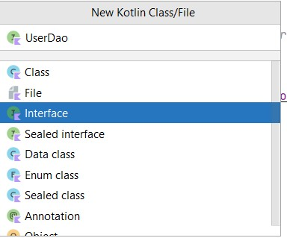

UserDao interface code:

[https://github.com/smartinternz02/SnackOrdering/tree/main/app/src/main/java/com/e xample/snackordering/UserDao.kt](https://github.com/smartinternz02/SnackOrdering/tree/main/app/src/main/java/com/example/snackordering/UserDao.kt)

Step 3 : Create an UserDatabase class



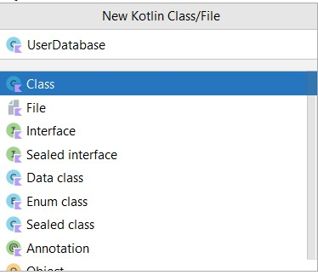

UserDatabase class code :

[https://github.com/smartinternz02/SnackOrdering/tree/main/app/src/main/java/com/e xample/snackordering/UserDatabase.kt](https://github.com/smartinternz02/SnackOrdering/tree/main/app/src/main/java/com/example/snackordering/UserDatabase.kt)

Step 4 : Create an UserDatabaseHelper class



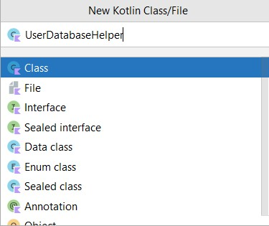

UserDatabaseHelper class code :

[https://github.com/smartinternz02/SnackOrdering/tree/main/app/src/main/java/com/e xample/snackordering/UserDatabaseHelper.kt](https://github.com/smartinternz02/SnackOrdering/tree/main/app/src/main/java/com/example/snackordering/UserDatabaseHelper.kt)

Database 2

Step 1 : Create Order data class



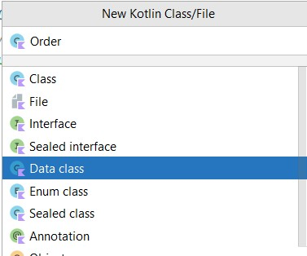

Order data class code:

[https://github.com/smartinternz02/SnackOrdering/tree/main/app/src/main/java/com/e xample/snackordering/Order.kt](https://github.com/smartinternz02/SnackOrdering/tree/main/app/src/main/java/com/example/snackordering/Order.kt)

Step 2 : Create OrderDao interface



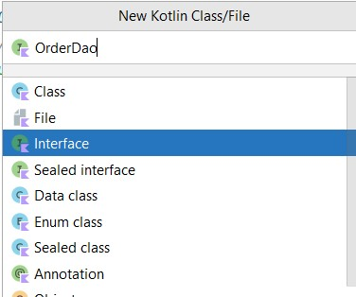

OrderDao interface code:

[https://github.com/smartinternz02/SnackOrdering/tree/main/app/src/main/java/com/e xample/snackordering/OrderDao.kt](https://github.com/smartinternz02/SnackOrdering/tree/main/app/src/main/java/com/example/snackordering/OrderDao.kt)

Step 3 : Create OrderDatabase class



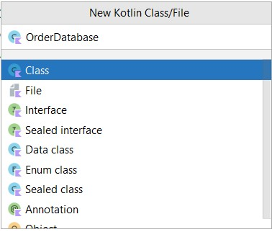

OrderDatabase class code:

[https://github.com/smartinternz02/SnackOrdering/tree/main/app/src/main/java/com/e xample/snackordering/OrderDatabase.kt](https://github.com/smartinternz02/SnackOrdering/tree/main/app/src/main/java/com/example/snackordering/OrderDatabase.kt)

Step 4 : Create OrderDatabaseHelper class



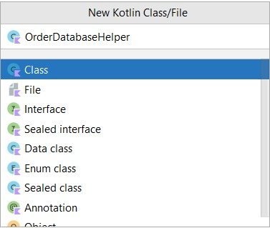

OrderDatabaseHelper class code:

[https://github.com/smartinternz02/SnackOrdering/tree/main/app/src/main/java/com/e xample/snackordering/OrderDatabaseHelper.kt](https://github.com/smartinternz02/SnackOrdering/tree/main/app/src/main/java/com/example/snackordering/OrderDatabaseHelper.kt)

**Task 5:**

Building application UI and connecting to database.

Step 1: Creating LoginActivity.kt with database

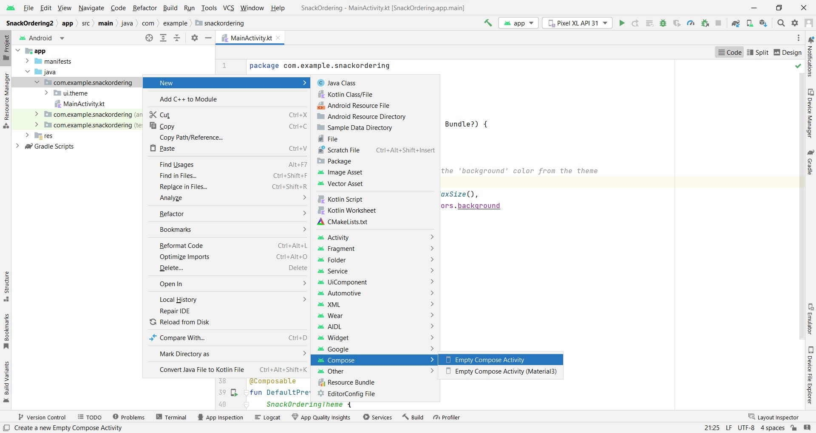

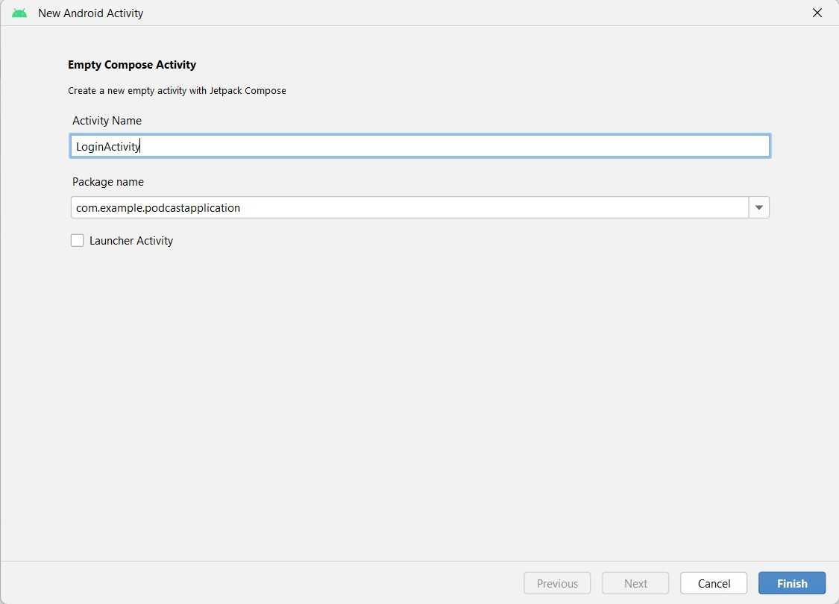

Database connection in LoginActivity.kt

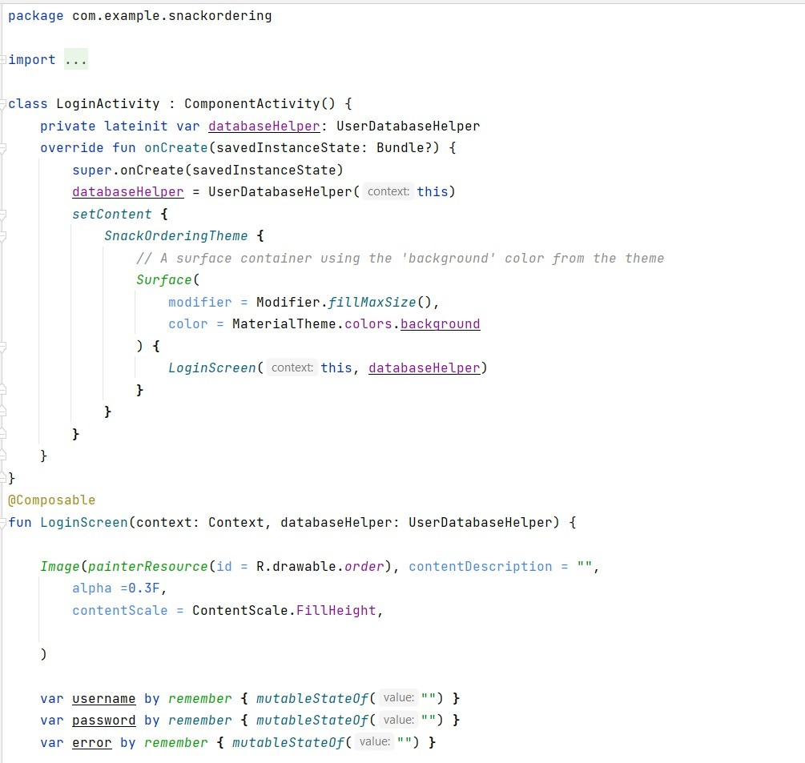

Complete code in below link: [https://github.com/smartinternz02/SnackOrdering/tree/main/app/src/main/java/com/e xample/snackordering/LoginActivity.kt](https://github.com/smartinternz02/SnackOrdering/tree/main/app/src/main/java/com/example/snackordering/LoginActivity.kt)

Step 2 : Creating MainActivity.kt with database

MainActivity is converted into RegisterActivity.kt as follows below:

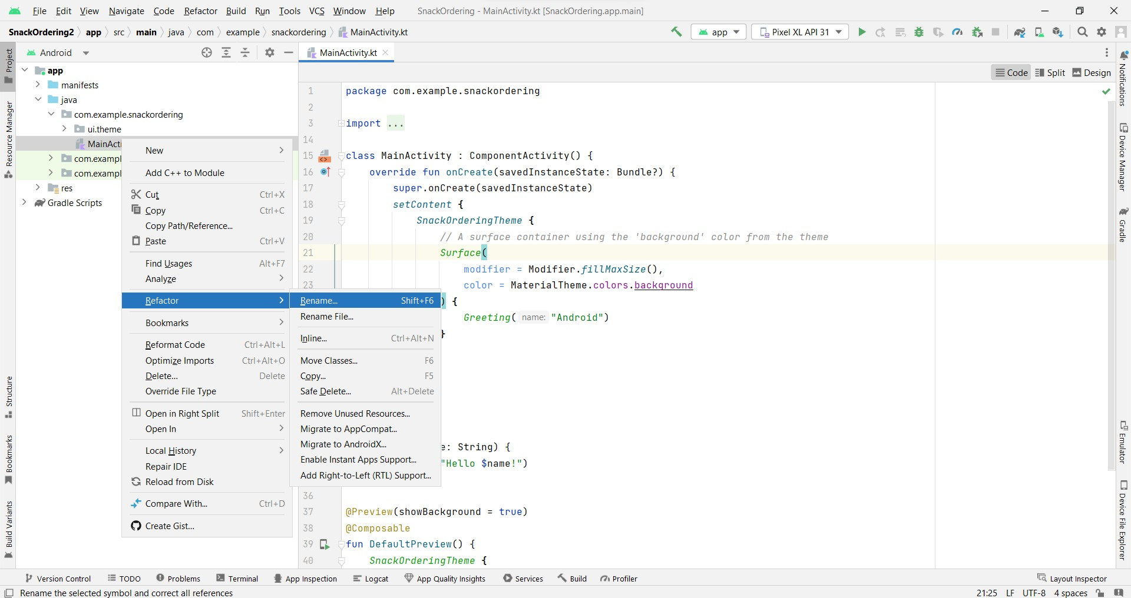

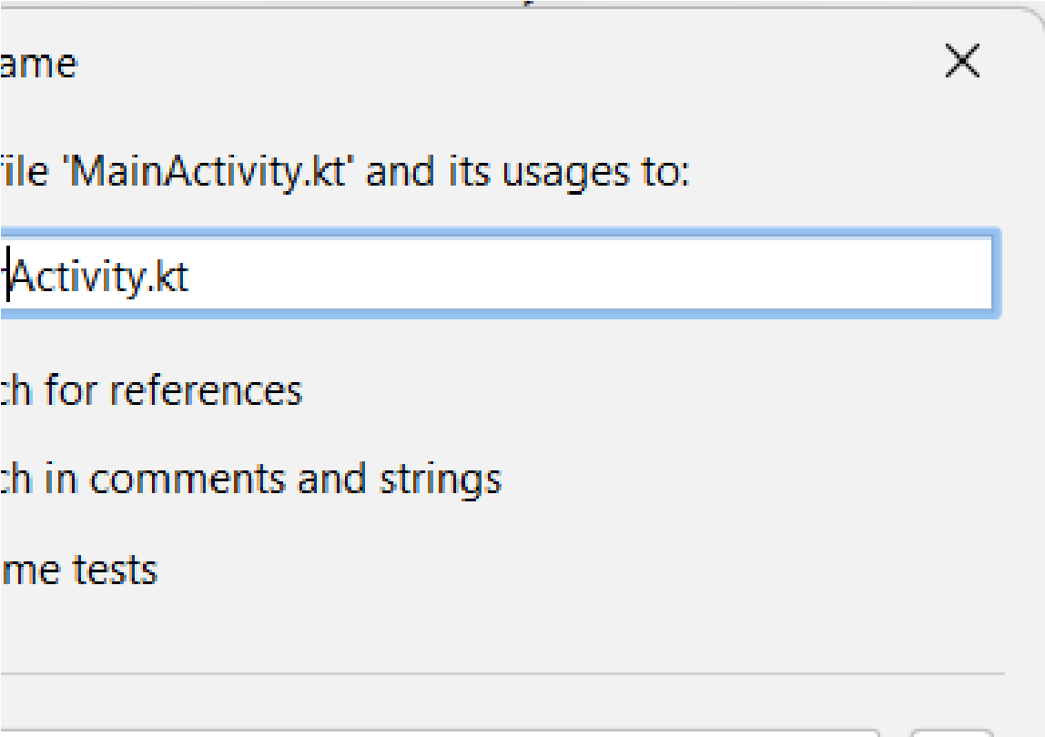

Now click on the Refactor.



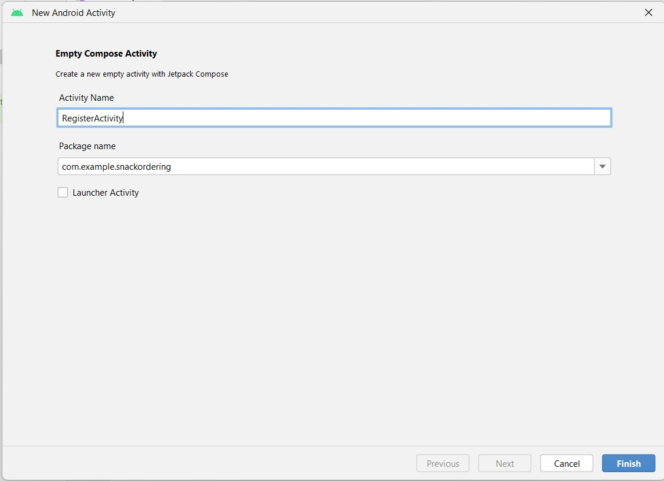

Database connection in RegisterActivity.kt

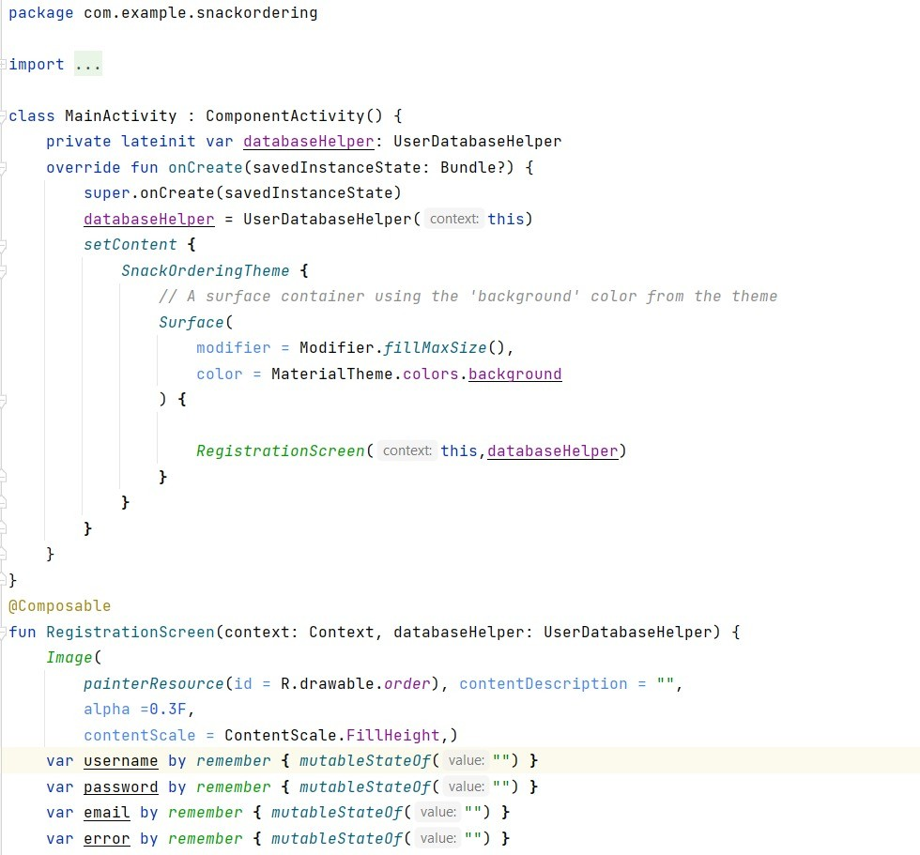

Complete code in below link:

[https://github.com/smartinternz02/SnackOrdering/tree/main/app/src/main/java/com/e xample/snackordering/RegisterActivity.kt](https://github.com/smartinternz02/SnackOrdering/tree/main/app/src/main/java/com/example/snackordering/RegisterActivity.kt)

Step 3 : Creating MainPage.kt file



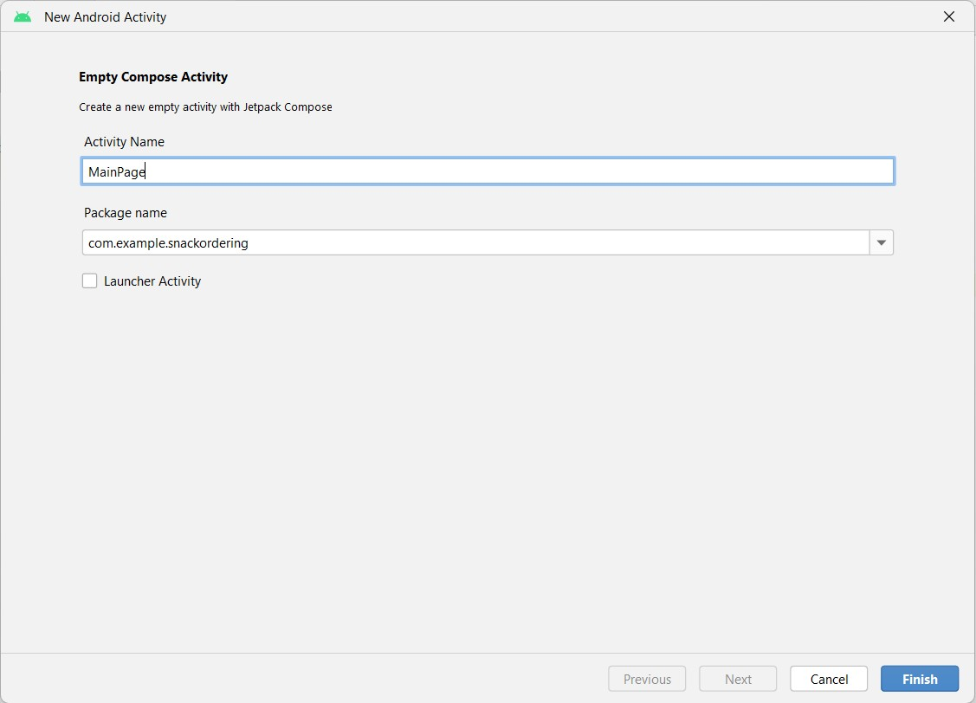

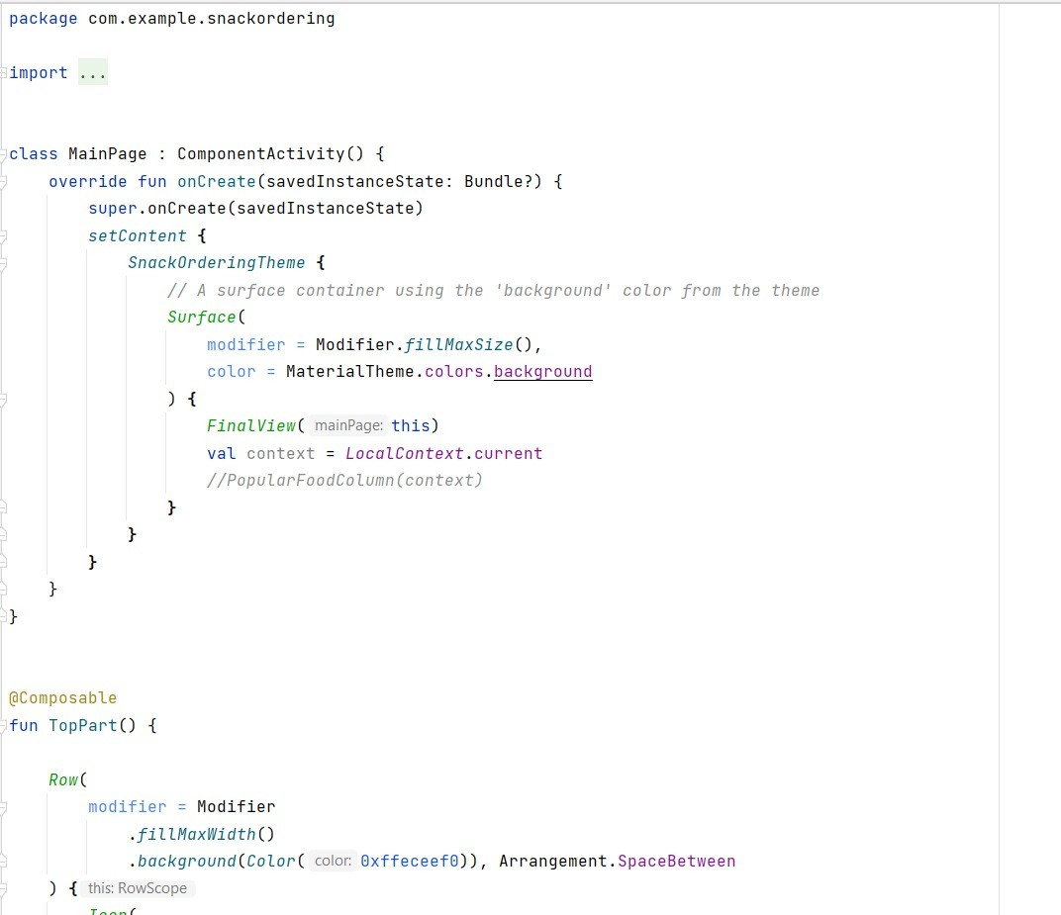

In MainPage.kt file the main application is developed

● Before creating UI we need to add some images in drawables which are in res

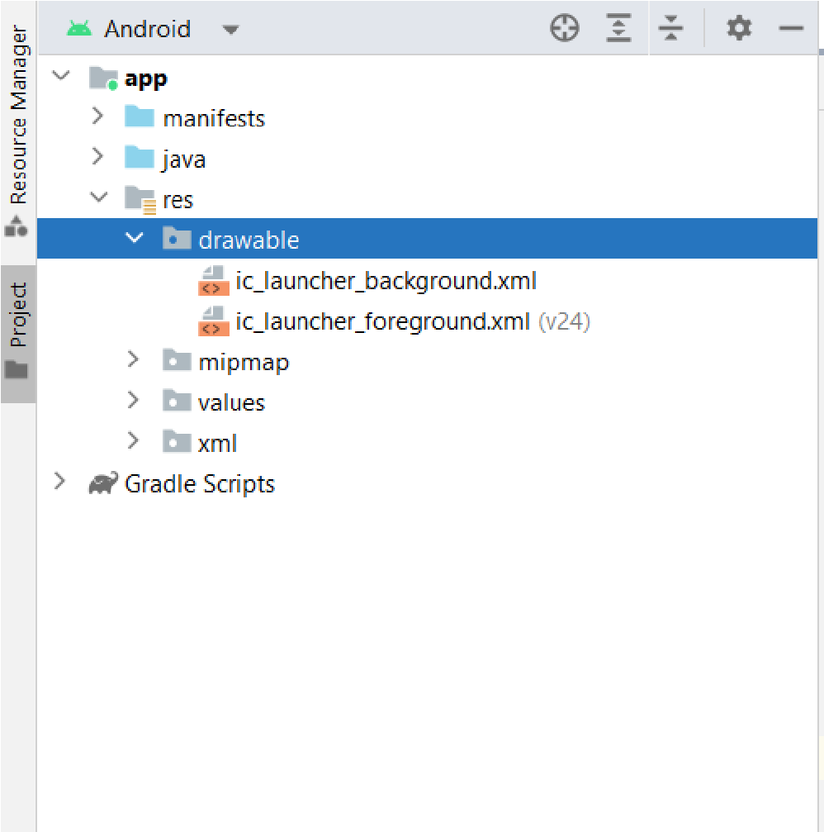

Download the required drawable from the code:

[https://github.com/smartinternz02/SnackOrdering/tree/main/app/src/main/res/drawab le-nodpi](https://github.com/smartinternz02/SnackOrdering/tree/main/app/src/main/res/drawable-nodpi)

Complete code of MainPage.kt :

[https://github.com/smartinternz02/SnackOrdering/tree/main/app/src/main/java/com/e xample/snackordering/MainPage.kt](https://github.com/smartinternz02/SnackOrdering/tree/main/app/src/main/java/com/example/snackordering/MainPage.kt) Step 4 : Creating TargetActivity.kt



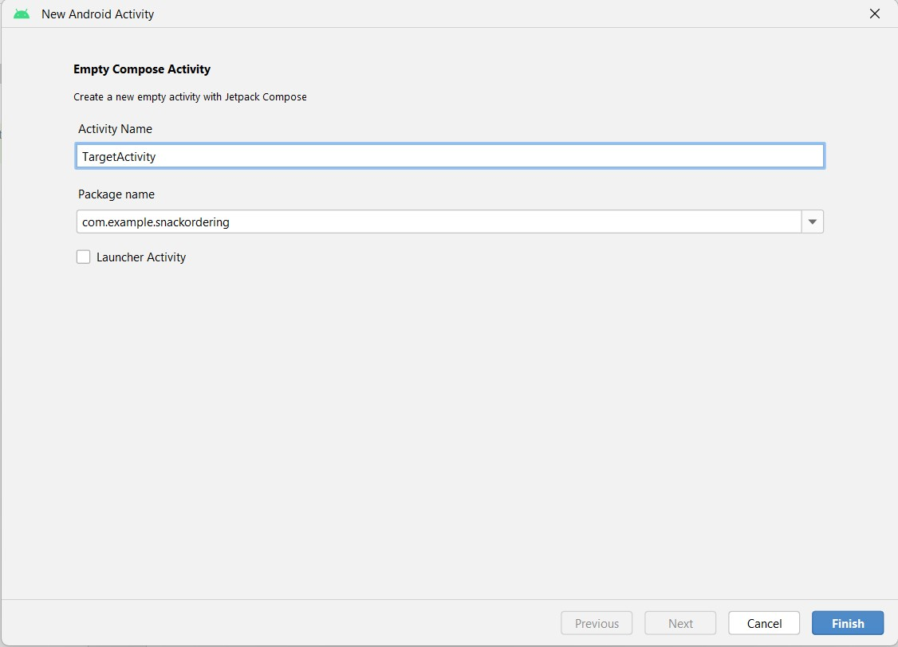

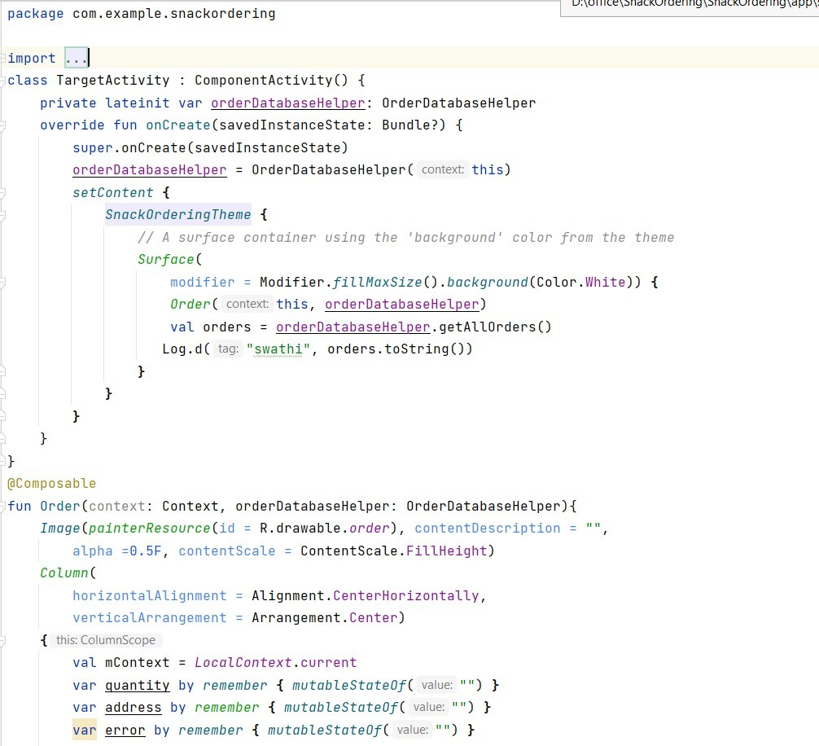

Complete code of TargetActivity.kt : [https://github.com/smartinternz02/SnackOrdering/tree/main/app/src/main/java/com/e xample/snackordering/TargetActivity.kt](https://github.com/smartinternz02/SnackOrdering/tree/main/app/src/main/java/com/example/snackordering/TargetActivity.kt) Step 4 : Creating AdminActivity.kt



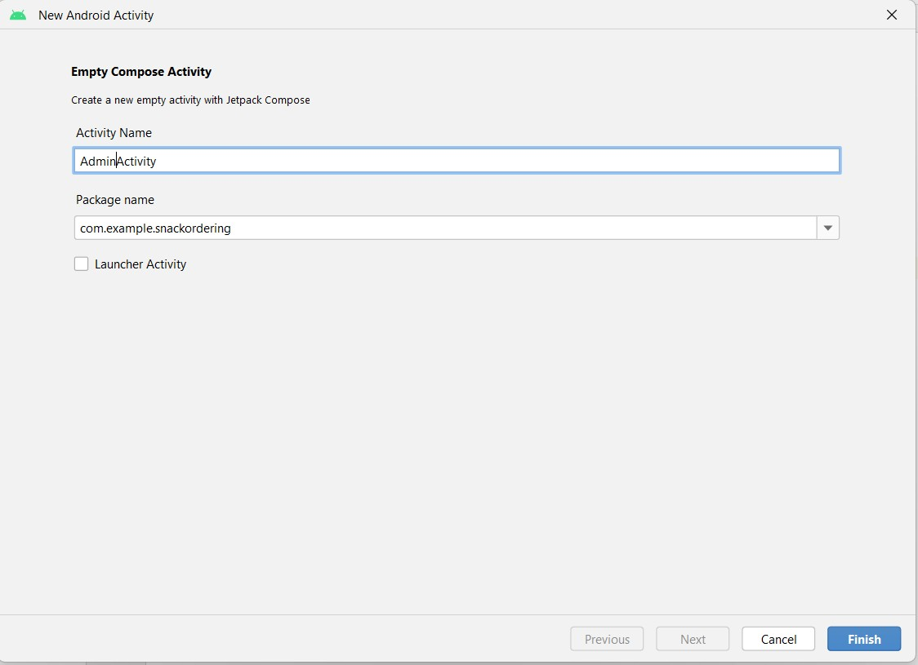

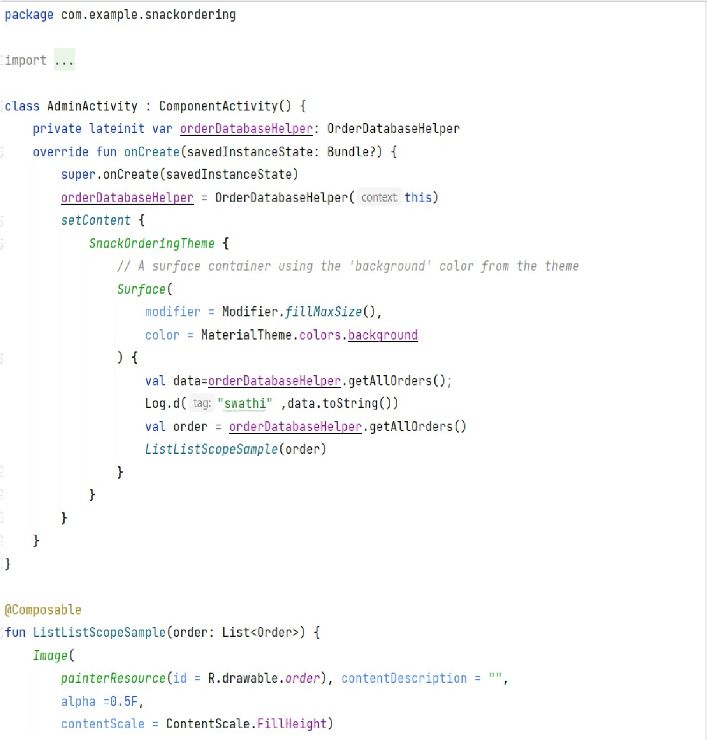

Complete code of AdminActivity.kt : [https://github.com/smartinternz02/SnackOrdering/tree/main/app/src/main/java/com/e xample/snackordering/AdminActivity.kt](https://github.com/smartinternz02/SnackOrdering/tree/main/app/src/main/java/com/example/snackordering/AdminActivity.kt)

**Task 6:**

Modifying AndroidManifest.xml

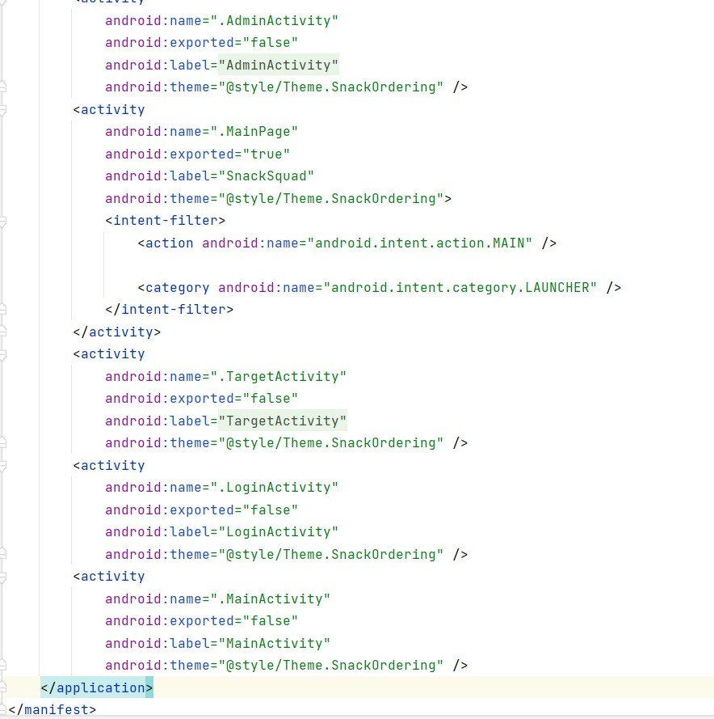

When we run the app we will get the MainActivity.kt file as our first screen , but we want LoginActivity.kt , So we need to change in AndroidManifest.xml.

Changed AndroidManifest.xml.

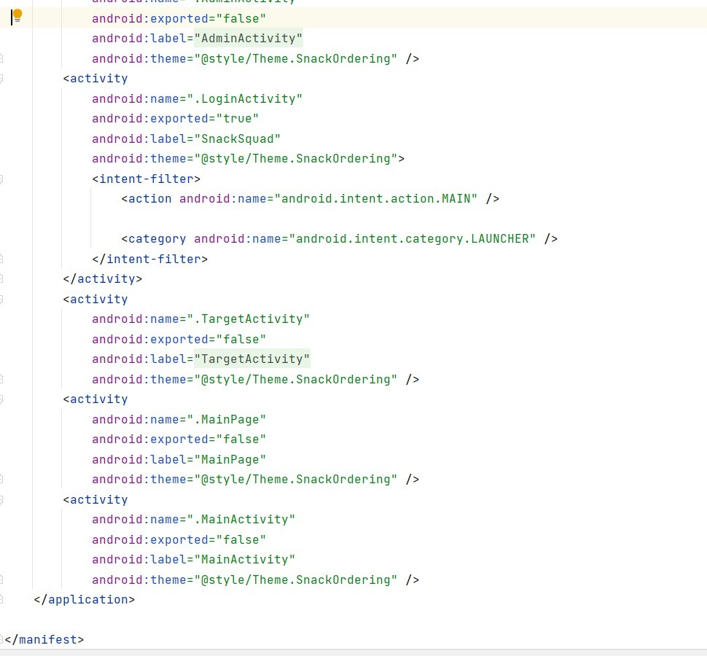

Complete AndroidManifest.xml code:@

[https://github.com/smartinternz02/SnackOrdering/blob/main/app/src/main/AndroidMa nifest.xml](https://github.com/smartinternz02/SnackOrdering/blob/main/app/src/main/AndroidManifest.xml)

**Task 7:**

Running the application.

Step 1: Run apps on a hardware device

<https://developer.android.com/studio/run/device>

Step 2: Run the application in Mobile

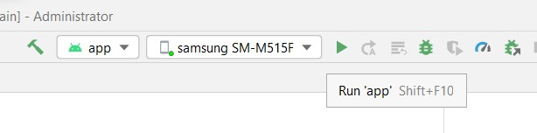

**Complete Project Link:**

[**https://github.com/smartinternz02/SnackOrdering**](https://github.com/smartinternz02/SnackOrdering)

**Final Output of the Application :**

Admin Module: After logging in with Admin Credentials which are hard coded.

Login Page :

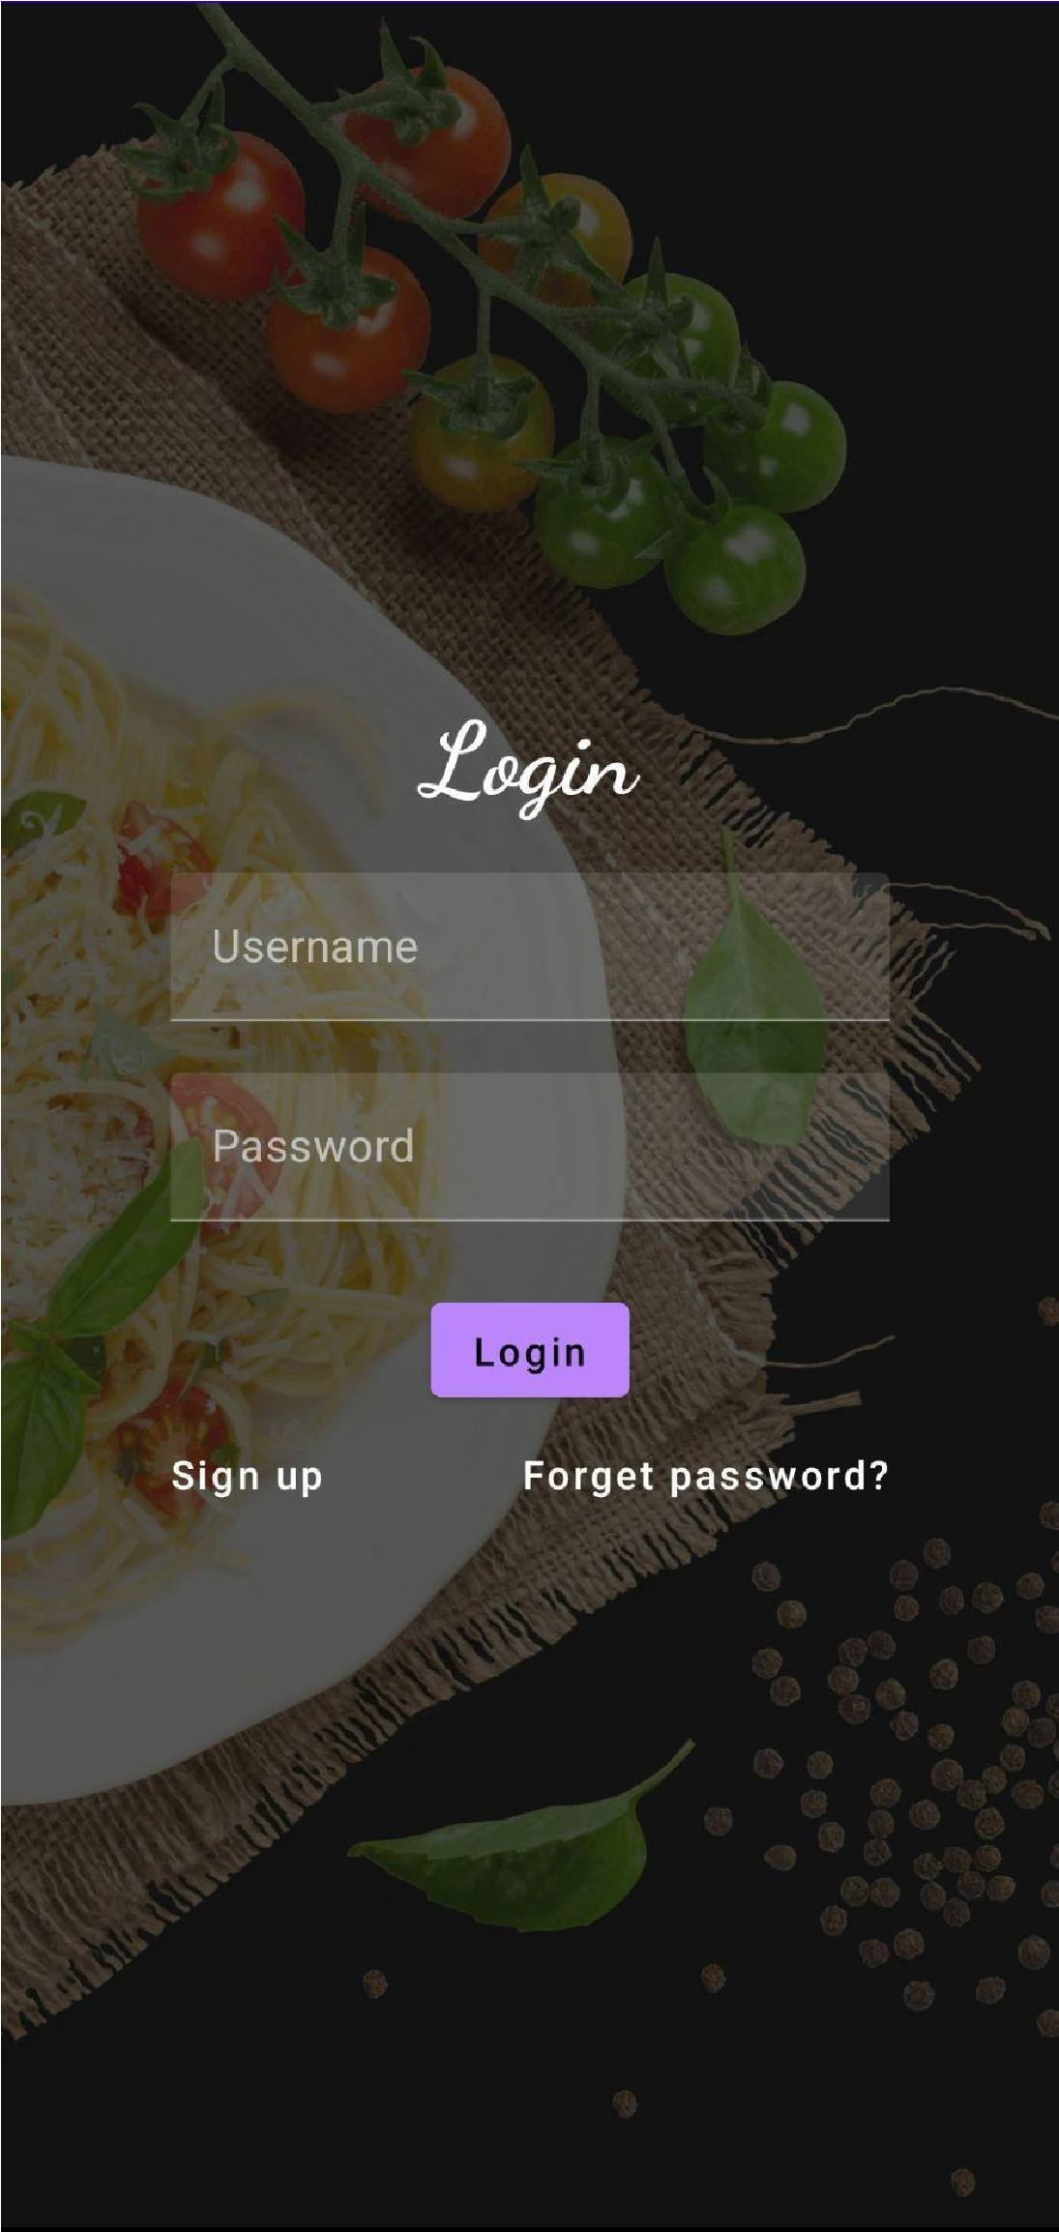

Register Page :

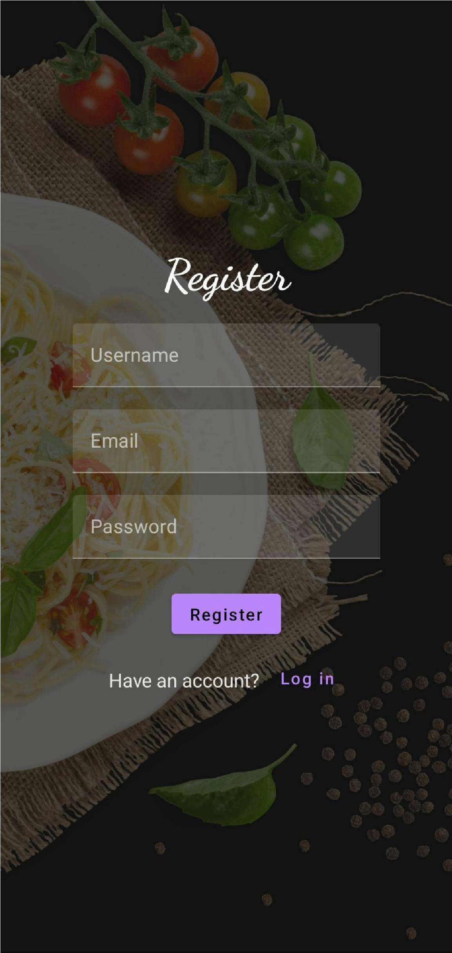

After logging in with Admin Credentials which are hard coded. Password must be “admin” .

Admin page:

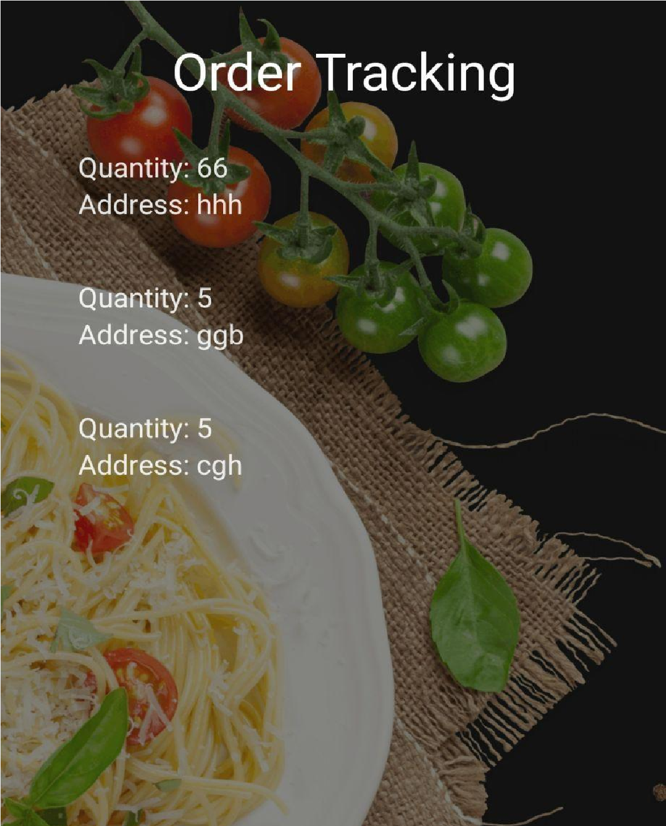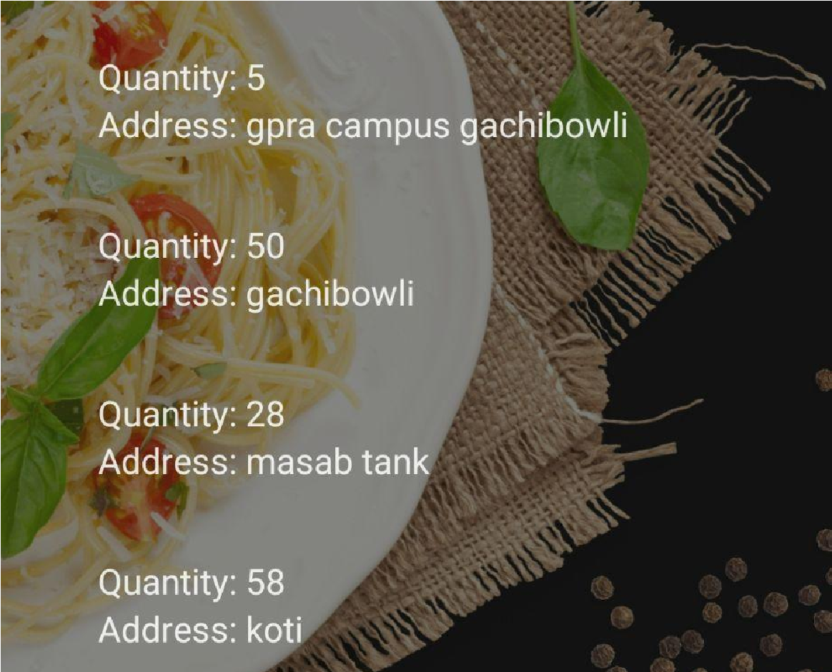

User Module: Login Page :

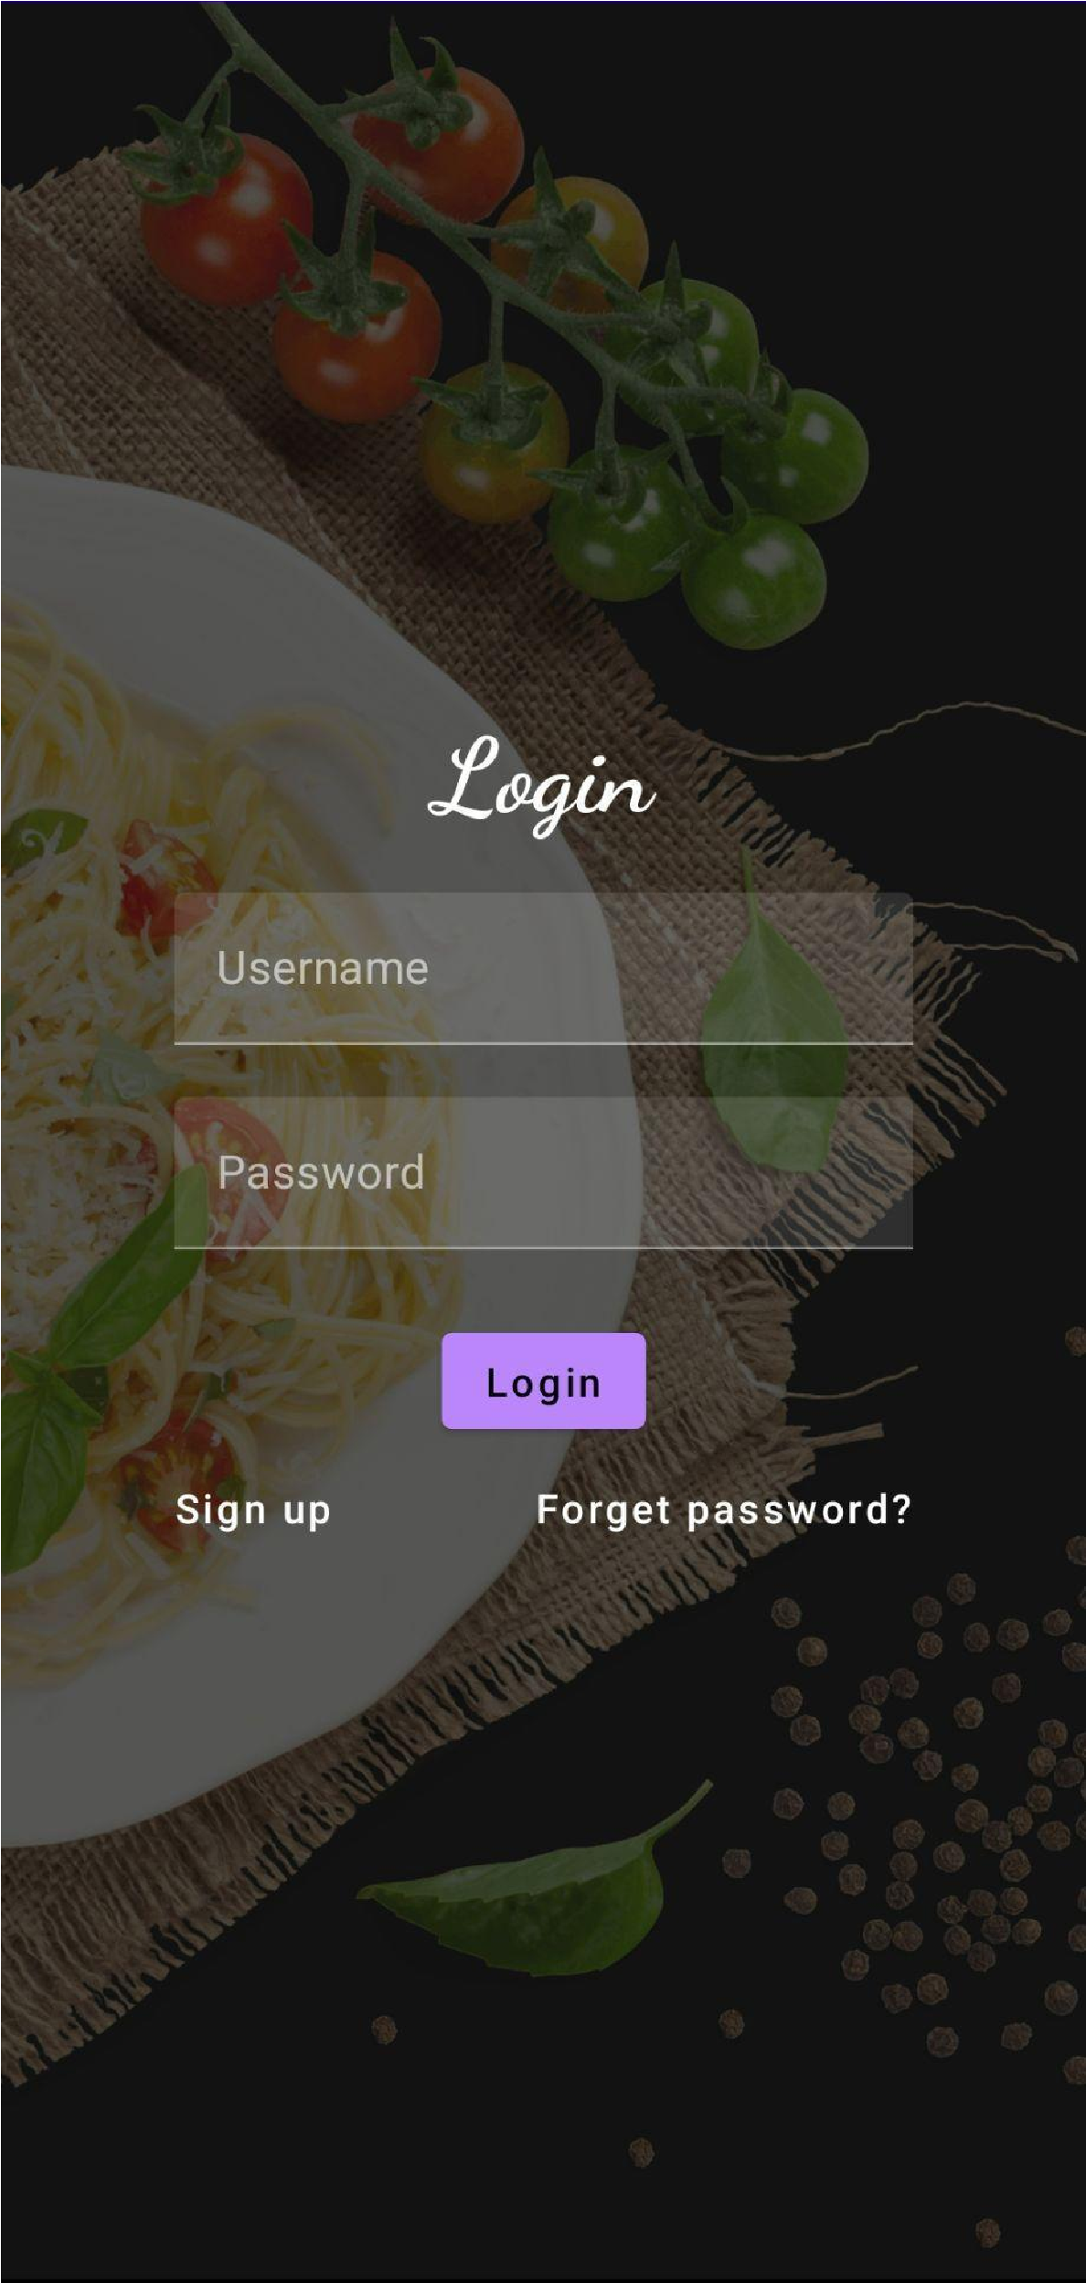

Register Page :

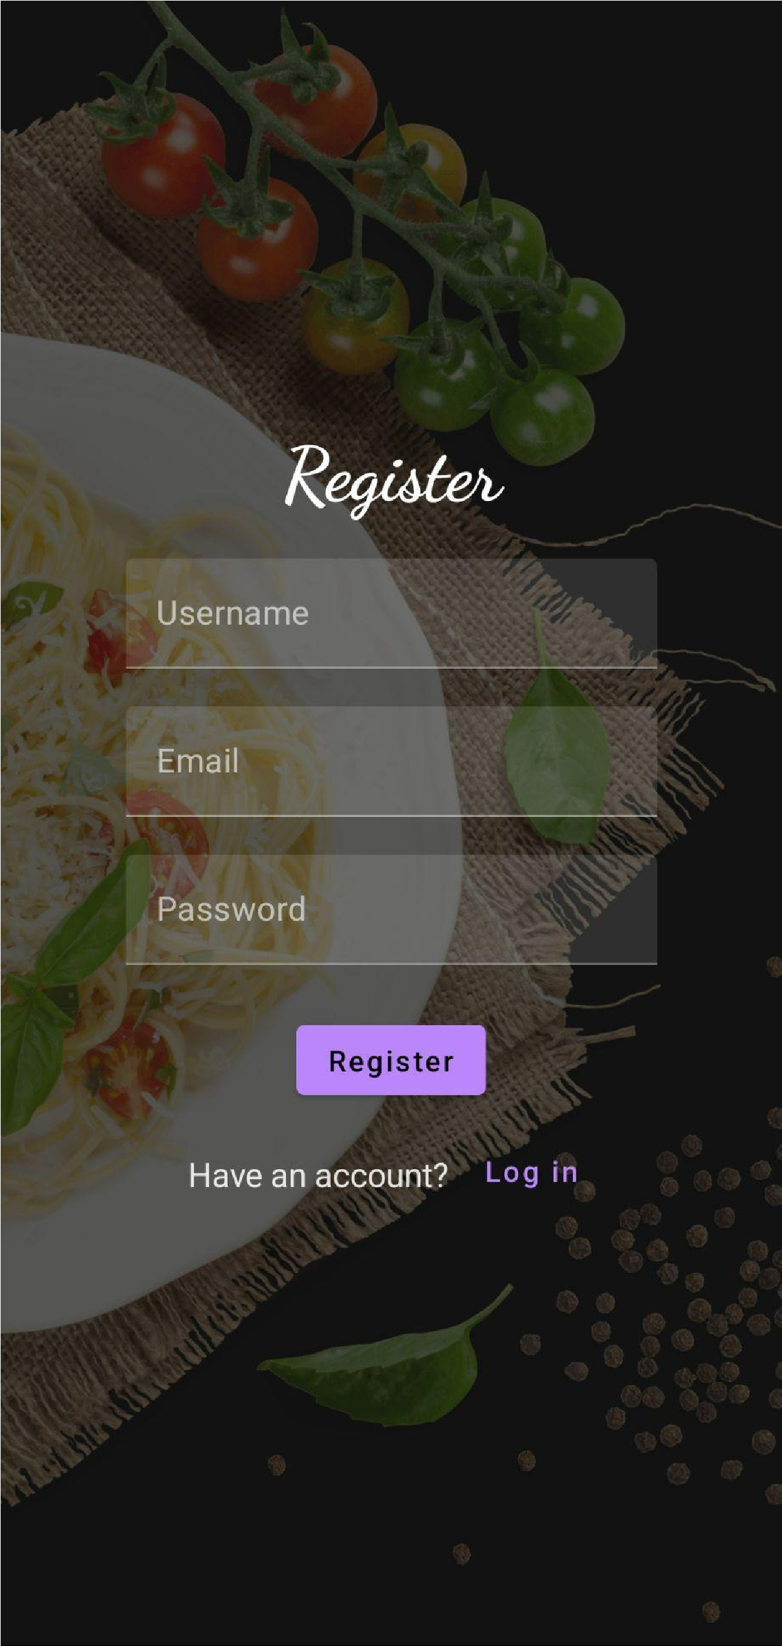

Main Page :

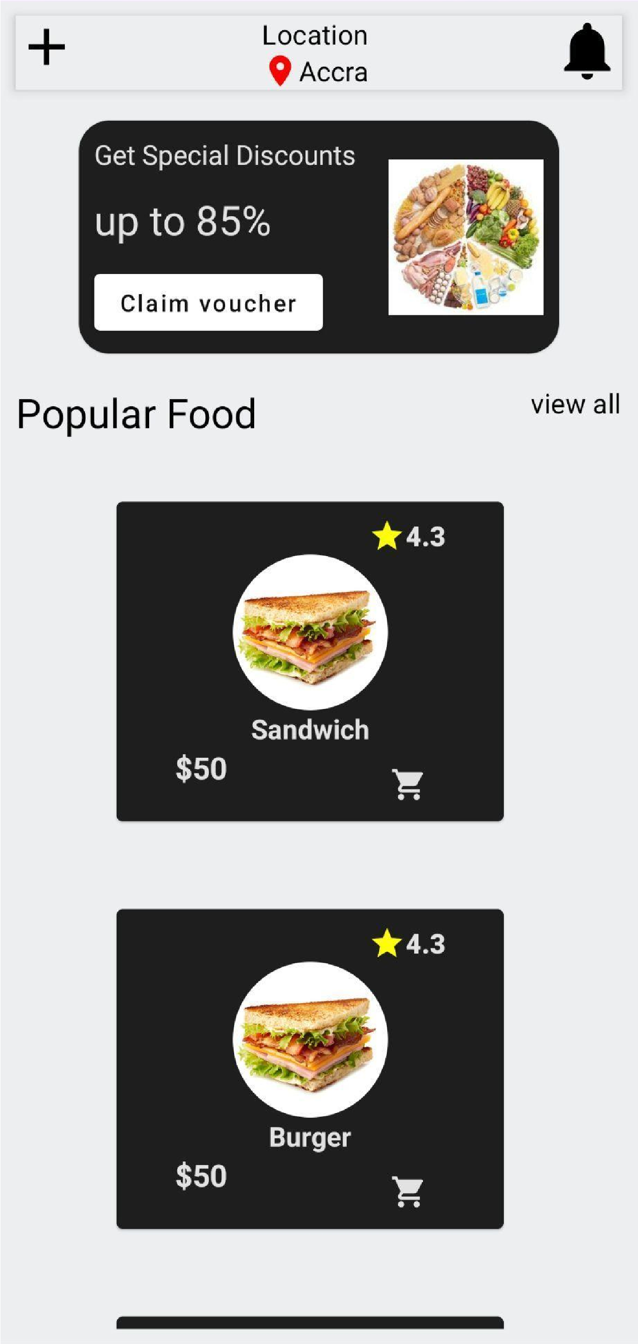

Order Page :

